

**American International University-Bangladesh (AIUB)**

**Faculty of Science and Technology (FST)**

**Department of Computer Science (CS)**

**SDPM Group Project, Spring 2023**

**Project Title: JobConnect - Simplifying Job Search and Recruitment.**

**Section: B**

**Submitted by**

|  |  |
| --- | --- |
| **Name** | **ID** |
| Abdullah Rayed | 20-41846-1 |
| Minhaz Ahmed Ayon | 20-41859-1 |
| Tahamidul Haque | 20-42139-1 |
| Naimah Salsabil Chowdhury | 20-42502-1 |

**1. Introduction:**

The development of a software system that will allow job seekers to look for employment possibilities and companies to post job openings is described in this project plan document. The aim of this document is to outline the project's goals, stakeholders, feasibility, budget and schedule in detail. Project sponsors, team members, and other important parties are among the target audience for this document. This document's objectives are to establish a roadmap for the project's effective completion and to make sure that all stakeholders have a clear grasp of the project's scope, timeline, budget, and deliverables.

**2. Project Title:**

JobConnect - Simplifying Job Search and Recruitment.

**3. Objectives and Scopes:**

The overall objective of this system is to create a comprehensive job search and vacancy posting platform that connects job seekers and employers in an efficient and user-friendly manner. The specific goals of the project are:

* To provide job seekers with an advanced search capability that enables them to find job openings based on their preferences, skills, and experience.
* To deliver a personalized job recommendation system that suggests relevant job openings to job seekers based on their profiles and job search history.
* To enable employers to post job vacancies and manage the recruitment process through a user-friendly interface.
* To provide a range of additional features, such as career advice, interview preparation and a way to directly message employers will help job seekers enhance their employability.
* To incorporate robust security measures to protect the personal information of job seekers and employers.
* To ensure the scalability and reliability of the platform by leveraging best practices in software development.

**4. Justification:**

This platform is made to solve the difficulties and pain points that exist in the present labor market for both companies and job seekers. The platform will offer a complete solution that streamlines the hiring and job seeking processes while also giving a number of extra features that improve job seeker's employability. Job seekers will benefit from the system by giving them a simple and effective way to browse for positions that match their qualifications, experience, and interests. The platform will also help employers by giving them a productive way to manage the hiring process and advertise job openings. This will simplify the recruiting procedure and enhance the outcome. By streamlining the hiring and job searching processes, increasing the employability of job seekers and optimizing company hiring outcomes, this technology will ultimately benefit the whole labor market ecosystem.

**5. Systems Overview:**

The proposed software development project is a web-based and mobile-based application that serves as a platform for connecting job seekers and employers. A job search and application system for job seekers and a job advertising and candidate management system for companies make up the system's two primary parts. Users of the job search and application system can look for open positions using a variety of parameters, including area, job title, and company name. Through the site, users may upload their resumes and cover letters in order to browse job descriptions and apply for openings. Employers may post job openings and handle candidate applications using the job posting and candidate management system's centralized dashboard. Companies may review candidate resumes and applications and customize job postings with specific requirements and qualifications. The system has features for interview scheduling, candidate screening, and communication with applicants.

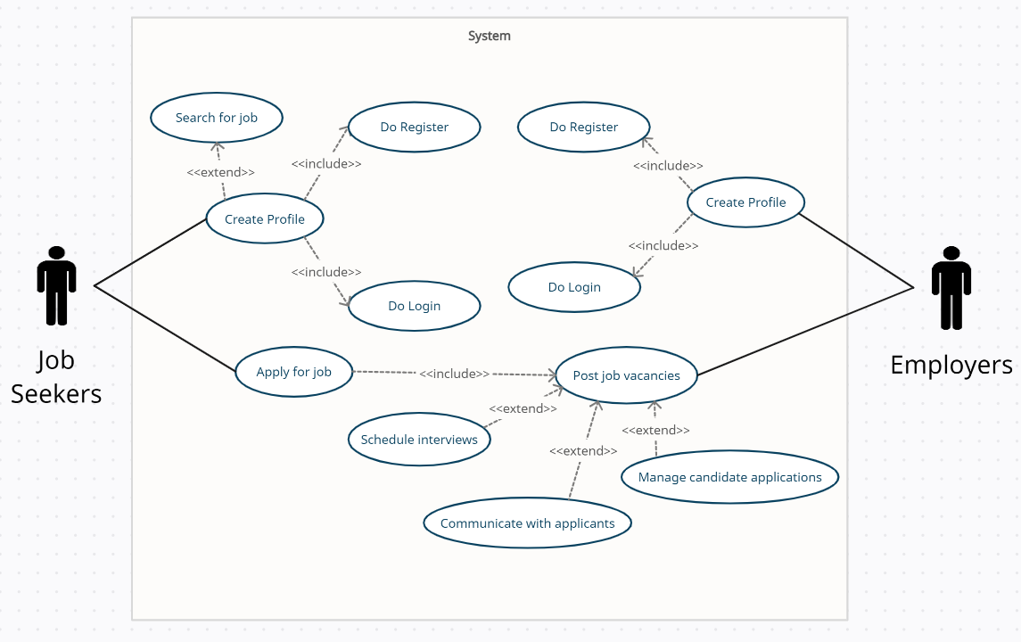

Fig 1 - Use Case Diagram

**6. Stakeholders Analysis:**

**Primary Stakeholders:**

* Investors: Investors are the main parties involved in the project because they will be funding it. They are interested in the return on their investment since they have a financial stake in the project's success.
* Project Sponsors: Organizations that are in charge of supervising the progress of the project are known as project sponsors. They care about completing the job on schedule, within budget, and to the required quality standards.

**Secondary Stakeholders:**

* Developers: Developers will create, implement, and utilize the software system. They are directly responsible for the project's success and will be in charge of making sure the software system complies with the project's specifications.
* Project Managers: Project managers are responsible for ensuring that the project is completed on time, within budget and to the required quality standards. They have a direct impact on the project's success and will be responsible for managing the resources, timelines, and risks associated with the project.
* Job Seekers: Job seekers are the end users of the platform who will use the software system to search for job openings, build resumes, and enhance their employability. They have a direct interest in the platform's usability, reliability and effectiveness in helping them find suitable job opportunities.
* Employers: Employers are also the end users of the platform who will use the software system to post job vacancies and manage the recruitment process. In order to find suitable candidates quickly and efficiently, they have a direct interest in the platform's effectiveness in helping them.

Other Stakeholders:

* Government: Government agencies that have a regulatory role in overseeing the job market are stakeholders that can positively or negatively affect the project. They have an interest in ensuring that the software system complies with relevant laws, regulations, and standards.
* Competitors: Competitors are other organizations or platforms that offer similar services or solutions to job seekers and employers. They have a direct interest in the platform's features, pricing, and market share.

**7. Feasibility Study:**

Before kicking off the development of the project, a feasibility study to determine the technical

and financial viability is a must.

**Technical Feasibility:**

The technical feasibility of the project can be evaluated by analyzing the availability and suitability of the necessary hardware, software, and human resources. The required infrastructure and expertise are readily available and can be acquired and deployed. Additionally, the necessary software components for developing such a system are widely available.

**Financial Feasibility:**

The financial feasibility of the project can be assessed by examining the project's costs, benefits and return on investment. The project's costs are estimated based on the requirements and specifications outlined in the project plan. The analysis finds that the project's expected benefits, such as increased efficiency in the job search process and improved talent acquisition for employers, would significantly outweigh the project's costs. The return on investment is estimated to be satisfactory.

Overall, the feasibility study concluded that the project is technically and financially feasible and has strong potential for success.

**8. Systems Component:**

The system will consist of several components working together to provide a comprehensive solution for job seekers and employers. The major components of the system are as follows:

* User Interface: This component offers the user interface for the system. It includes the platform's look, feel, and operation on the web and mobile devices.
* Job Search Engine: This feature enables job searchers to filter their job searches based on parameters like region, pay, and job type. Modern search techniques will be used in the construction of the job search engine to deliver precise and relevant results.
* Job Posting Engine: This component allows employers to post job vacancies within the platform. Employers will be able to create and manage job postings, set criteria for applicants, and communicate with applicants through the platform.
* Application Management: This component provides employers with the ability to manage job applications within the platform. Employers will be able to review and respond to job applications, as well as communicate with applicants through the platform
* Security and Authentication: This component ensures that the platform is secure and that user data is protected. The security and authentication component include features such as two-factor authentication, and SSL encryption. These components will work together to provide a user-friendly, secure and comprehensive job search and vacancy posting platform for job seekers and employers.

**9. Process model to be followed:**

For this project, the Agile software development process will work well. Agile is an incremental, iterative process approach that places a focus on communication, adaptability, and the quick delivery of functional software. Agile enables adjustments to be made as the project progresses based on input from stakeholders, which is particularly crucial for a project that involves user engagement. In order to ensure that the software is continuously tested and verified throughout the development process, it also stresses providing functioning software in brief cycles. Agile encourages team cooperation between stakeholders, end users, and the development team, ensuring that everyone is on the same page and working toward the same objectives. With ongoing testing and validation, this method provides early risk detection and reduction. Agile focuses on delivering high-quality software by emphasizing testing and validation throughout the development process. Lastly, agile emphasizes transparency by providing stakeholders with visibility into the development process of the project. By using the Agile process model, we can ensure that the project is delivered on time, within budget, and to the satisfaction of all stakeholders.

**10. Efforts Estimation:**

Work breakdown structure of programmers needed for the project:

1. UI Designer

* UI design
* Front-end development
* User testing and feedback

1. Search Engine Developer

* Search algorithm design
* Search engine development
* Integration with UI
* Testing and validation

1. Back-end Developer

* Job posting management system development
* Job application management system development
* Employer and applicant account management system development
* Employer and applicant messaging system development
* Integration with UI
* Testing and validation

1. Data Analyst

* Data collection system development
* Data analysis system development
* Integration with UI
* Testing and validation

1. Security Expert

* Security system development
* Authentication system development
* Integration with all other components
* Testing and validation

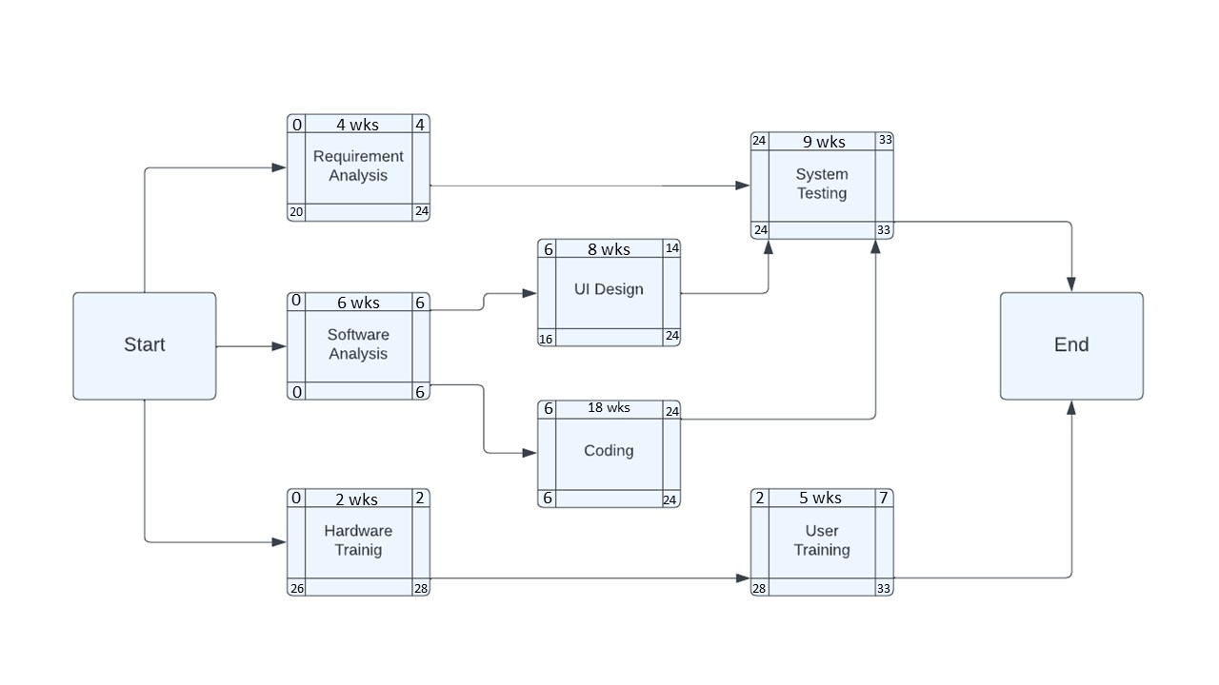**11. Activity Network Diagram:**

Fig 2 – Activity Network Diagram

**CRITICAL PATH:** Software Analysis 🡪 Coding 🡪 System Testing.

**12. Risk Analysis:**

Some potential risks for the project below-

|  |  |  |  |  |  |
| --- | --- | --- | --- | --- | --- |
| **Risks** | **Category** | **Probability (%)** | **Impact** | **Cost (TAKA)** | **RE** |
| Delivery deadline will be extended | BU | 25 | 2 | 60000 | 15000 |
| Technology will be changed | TE | 15 | 2 | 100000 | 15000 |
| Lack of experienced staffs | ST | 30 | 2 | 25000 | 7500 |
| Staff turnover during project | ST | 30 | 3 | 20000 | 6000 |
| Budgets overruns | DE | 20 | 1 | 80000 | 16000 |
| Project requirements change | PS | 20 | 2 | 17000 | 3400 |
| Security or data breaches | BU | 60 | 1 | 950000 | 570000 |

Impact values-

1 = catastrophic

2 = critical

3 = marginal

4 = negligible

**Risk Probability** = 80% (Most Likely)

**Risk Impact:** There are 7 components to be developed from scratch. Let, the average components are 204 LOC and local data indicate that the software engineering cost for each LOC is 500 Tk. So, the overall cost to develop the components could be 7 x 204 x 500 = 714,000 Risk Exposure = Probability x Cost = 0.80 x 714 ,000 Tk. = 570 ,000 Tk.

**13. Required Resources:**

Some of the key resources that are typically required to complete this software project is given below:

1. **Project Management:** A project manager is responsible for planning, organize, and managing the project resources to ensure that the project is completed on time, within budget, and to the required quality standards.
2. **Development Team:** A development team consisting of software developers, testers, and designers are required to design, develop, test, and deploy the software product.
3. **Software Infrastructure:** This includes the hardware and software infrastructure required to support the development, testing, and deployment of the software. This may include computers, servers, software tools, and other equipment required to support the development and testing of the software.
4. **Requirements and Design Documentation:** Documentation is required to capture the software requirements and design specification. This can include project plans, user requirements documents, functional specifications, and technical design documents.
5. **Communication and Collaboration Tools:** Effective communication and collaboration tools are essential to support communication among project team members, stakeholders, and customers. This can include email, chat, video conferencing, and other collaboration tools.
6. **Training and Support:** Once the software product is developed, training and support resources and required to help users learn how to use the software and to provide ongoing support to users.
7. **Quality Assurance and Testing:** Quality assurance and testing resources are required to ensure that the software product meets the required quality standards and is free from defects.

**14. Budget for the project:**

COCOMO (Constructive Cost Model) is a software cost estimation model that uses the size of the project, the team size, and other factors to estimate the effort required to develop software. There are three versions of COCOMO: Organic, Semi-detached, Embedded. Here, I will use the Organic version as it is the most commonly used one.

Effort = PM = Coefficient<Effort Factor>*(SLOC/1000)^P

Development time = DM = 2.50*(PM)^T

Required number of people = ST = PM/DM

PM: person-months needed for project

SLOC: source lines of code

P: project complexity (1.04-1.24)

DM - duration time in months for project

T: SLOC-dependent coefficient (0.32-0.38)

ST: average staffing necessary

Effort = PM = Cofficent<effort factor>*(SLOC/1000)^P

= 3.6*(10000/1000)^1.20

= 57.05

Development time = DM = 2.50*(PM)^T

=2.50*(57.05)^0.32

= 9.11

Required number of people = ST = PM/DM

= (57.05/9.11)

= 6.26

= 7

**Budget:**

7 developers working of 3 months:

Duration in weeks = 15 weeks

Office days = 5 days

Working hours = 8 Hours

So, per week working hours is = (5*8) hours = 40 hours

Hence, Total Working hours is = (40*15) hours

= 600 hours.

All Developer salary is = 800 BDT Per Hour

Total developers Salary = (800*600) BDT = 4,80,000 BDT

Utility cost : 50,000 BDT

Salary cost : 4,80,000 BDT

Components cost: 20,000 BDT

Revenue : 1,00,000 BDT

Total cost = 6,50,000 BDT

**15. Conclusion:**

In conclusion, the proposed software development project seeks to offer a platform for job searchers to look for and apply for open positions, as well as a way for companies to post employment openings and handle application management. With this initiative, we hope to offer a simple and effective solution that will help both businesses and job seekers. Together with the stakeholders and potential risks, we have determined the main system goals and component units. We have decided that the project is technically and financially feasible and have supplied a breakdown of the estimated budget for the team based on our feasibility analysis and effort calculation. By following the process model and work breakdown structure outlined in this proposal, we are confident that we can deliver a high quality and functional software system that meets the needs of our target users.